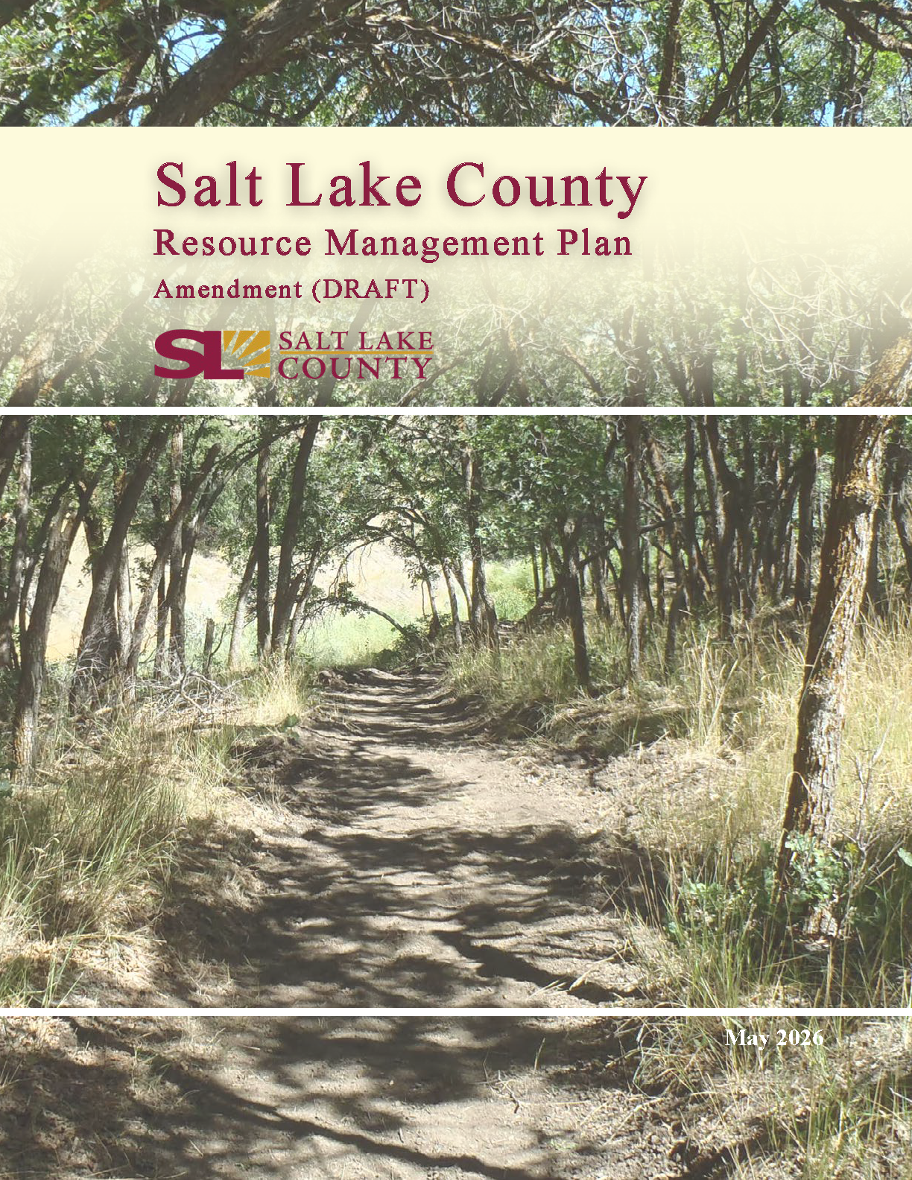

TERMS AND ABBREVIATIONS

County Resource Management Plan (CRMP)
Federal Energy Regulatory Commission (FERC)
Federal Land Policy and Management Act (FLPMA)
Foothill and Canyons Overlay Zone (FCOZ)
National Environmental Policy Act (NEPA)
National Forest Management Act (NFMA)
Open Access Transmission Tariff (OATT)
Pipeline and Hazardous Materials Safety Administration (PHMSA)
US Bureau of Land Management (BLM)
US Department of Transportation (DOT)
US Energy Information Administration (EIA)
US Environmental Protection Agency (EPA)
US Forest Service (Forest Service)
US Fish and Wildlife Service (USFWS)
US Geological Survey (USGS)
Utah Department of Environmental Quality (DEQ)
Utah Department of Transportation (UDOT)
Utah Geological Survey (UGS)
Utah Pollution Discharge and Elimination System (UPDES)

TABLE OF CONTENTS

1. Introduction 1
2. Renewable Energy 2
Management Setting 2
Desired Future State 3
Management Objective and Associated Policies and Guidelines 4
3. Critical Minerals and Rare Earth Elements 5
Management Setting 6
Desired Future State 6
Management Objective and Associated Policies and Guidelines 7
4. Utility Corridors 8
Management Setting 9
Desired Future State 10
Management Objective and Associated Policies and Guidelines 10
5. Pipelines and Infrastructure 11
Management Setting 11
Desired Future State 22
Management Objectives and Associated Policies and Guidelines 22

LIST OF TABLES

Table 3.1 Critical minerals located in Salt Lake County 6
Table 4.1 Existing major utility corridors 9
Table 5.1 Existing electrical transmission line length by type and voltage class 14
Table 5.2 Natural Gas Pipelines 15
Table 5.3 Existing oil pipeline length by product type and operator 16
Table 5.4 Existing and Proposed Fiber Optic Cable 17
Table 5.5 Active municipal sewer wastewater treatment facilities 18
Table 5.6 Existing and planned roadways length by functional class 19
Table 5.7 Shared Use Trails 20
Table 5.8 Existing railroad length by operator and division 21

Introduction

Utah State Code Section 17-79-402(2) (2025) requires each county in Utah to develop a County Resource Management Plan (CRMP) to define policy, goals, and objectives for managing natural resources on public lands as defined by Section 63L-6-102 (2025). Salt Lake County (County) adopted its first CRMP in 2017. In 2022, the Utah State Legislature added four new resource categories to be included in the mandated CRMPs. These new resource categories are (1) renewable energy, (2) critical minerals and rare earth elements, (3) pipelines and infrastructure, and (4) utility corridors. These resource categories have been added to the 2017 Salt Lake County CRMP by amendment.

The vast majority of public land in Salt Lake County is covered by the County’s Foothills and Canyons Overlay Zone (FCOZ), the purpose of which is to “promote safe, environmentally sensitive development that strikes a reasonable balance between the rights and long-term interests of property owners and those of the general public.” To this end, any activities that occur on these public lands will be required to meet FCOZ standards intended to preserve visual and aesthetic qualities (including ridgelines and natural contours), protect water quality, reduce natural hazard risk, and minimize disturbance.

This amendment was recommended for approval by the Salt Lake Planning Commission on ADD DATE and approved by the Salt Lake County Council on ADD DATE.
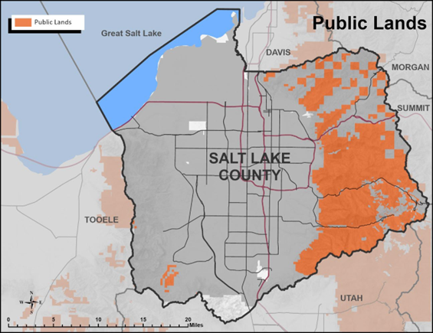

Renewable Energy

Renewable energy consists of energy produced from natural, replenishable sources. These include but are not limited to solar energy, geothermal resources, wind, and hydropower.

Related resources:
- Energy Resources
- Land Use
- Utility Corridors
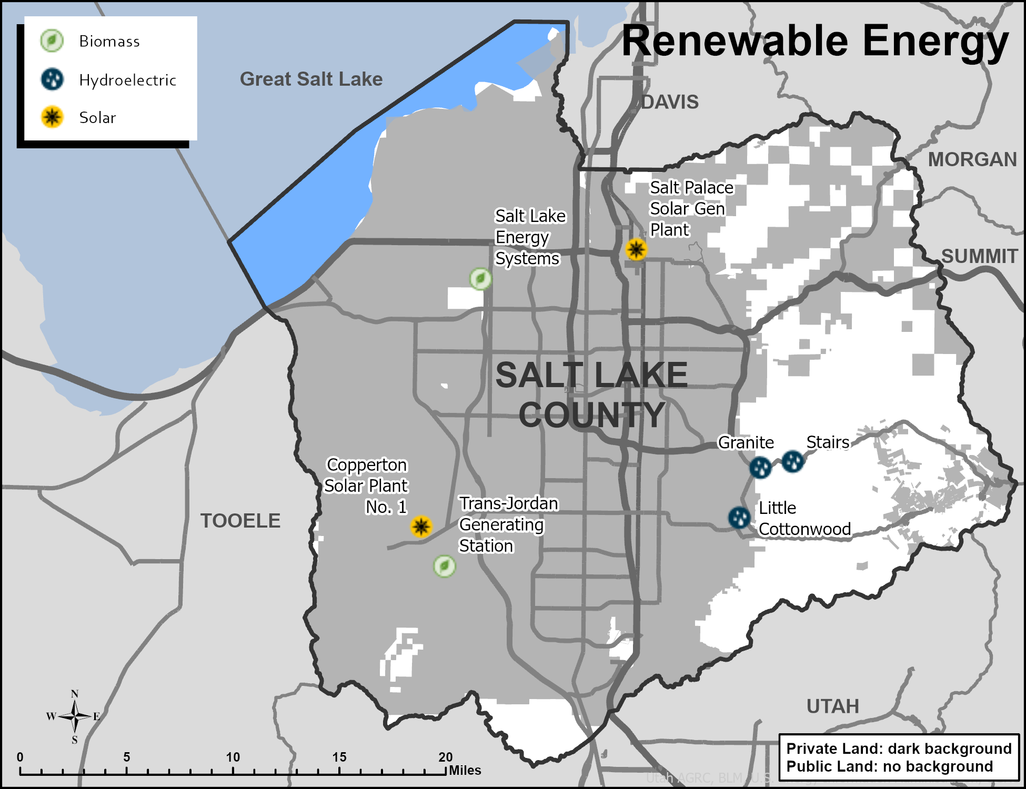
Source: Total Nameplate Capacity, Electrical Energy Infrastructure and Resources (EIA 2025).[1]

Management Setting

Resource Context
Compared to other counties in Utah, Salt Lake County has a relatively minor potential for renewable energy production on public lands. Statewide studies of renewable energy potential show limited resources in the County. Furthermore, restrictive land use designations, such as wilderness, watershed- protection areas, and FCOZ, preclude the development of most renewable energy sources in those areas.
The infrastructure required to harness renewable energy, such as solar arrays, wind turbines, and transmission lines is incompatible with critical visual resources that characterize the Wasatch Mountains.

Legal Context
Regulations on the placement of renewable energy infrastructure include federal and local land use laws. Most public lands in the County are within the Wasatch-Cache National Forest, which falls under the jurisdiction of the US Forest Service (USFS) as well as a small amount of land managed by the US Bureau of Land Management (BLM), found in the southwest corner of the county. The County’s FCOZ would also impose additional restrictions and regulations on any renewable energy infrastructure proposed in these areas.

Please see Chapter 13 Land Use for specific laws and procedures regulating allowable land uses on public lands.

Findings
Commercial-scale renewable energy generation capacity from existing facilities in the County is approximately 17.1 megawatts (MW) (Table 1), while energy production from other major sources, such as natural gas, is approximately 780 MW.[1]

Table 2.1. Major renewable energy generation by type and capacity (does not include private roof-top solar).
TYPE | NAME | CAPACITY (MW)
Hydroelectric | Little Cottonwood | 4.8
Hydroelectric | Granite | 2.0
Hydroelectric | Stairs | 1.0
Landfill Gas | Trans-Jordan Generating Station | 4.8
Landfill Gas | Salt Lake Energy Systems | 3.2
Solar | Salt Palace Solar Gen Plant | 1.3
Solar | Copperton Solar Plant No. 1 | 5.0
TOTAL |  | 22.1
Source: Total Nameplate Capacity, Electrical Energy Infrastructure and Resources (EIA 2025) [1].

Desired Future State

Because of the high priority placed on protecting the visual quality of the County’s public lands, aboveground, utility-scale renewable energy production using solar arrays or windmills is not appropriate on these lands. Other renewable energy production, such as hydropower or geothermal, may be appropriate when visual impacts or impacts to other resources are mitigated. The County desires active participation in decisions related to new renewable energy developments on public lands. The County encourages the use of renewable energy produced locally by individual consumers, such as rooftop solar, or as provided by utility companies.

Management Objective and Associated Policies
and Guidelines

Management Objective
Renewable energy projects have minimal impacts on the County’s natural and visual resources.

Policies and Guidelines
- Renewable energy projects shall comply with County ordinance in the Chapter titled “Foothills and Canyons Overlay Zone (FCOZ in areas subject to that ordinance including slope-protection standards, skyline and ridgeline development designations, and tree and vegetation Protection requirements.
- Participate in planning processes and land use decisions related to renewable energy activities on public lands.
- Coordinate with federal and state agencies in approval of new operations.
- Encourage residents and businesses to install small-scale renewable energy facilities on privately owned properties and/or participate in utility-provided renewable-energy programs.
- Collaborate with utility providers and developers to consider renewable energy production, energy efficiencies, and smart-grid technologies.

References

[1] US Energy Information Administration. 2025. Power Plants in the U.S. [GIS Feature Server]. https://services2.arcgis.com/FiaPA4ga0iQKduv3/arcgis/rest/services/Power_Plants_in_the_US/FeatureServer.

Critical Minerals and Rare Earth Elements

Critical minerals and rare earth elements are those non-fuel minerals that are critical to manufacturing, renewable energy generation, technology, and national security. The resources often have foreign origins or are otherwise vulnerable to supply-chain disruptions that could have negative impacts on the economy and national security. These definitions do not include “critical infrastructure materials” such as sand, gravel, or rock aggregate.

Related resources:
- Land Use
- Mineral Resources
- Mining

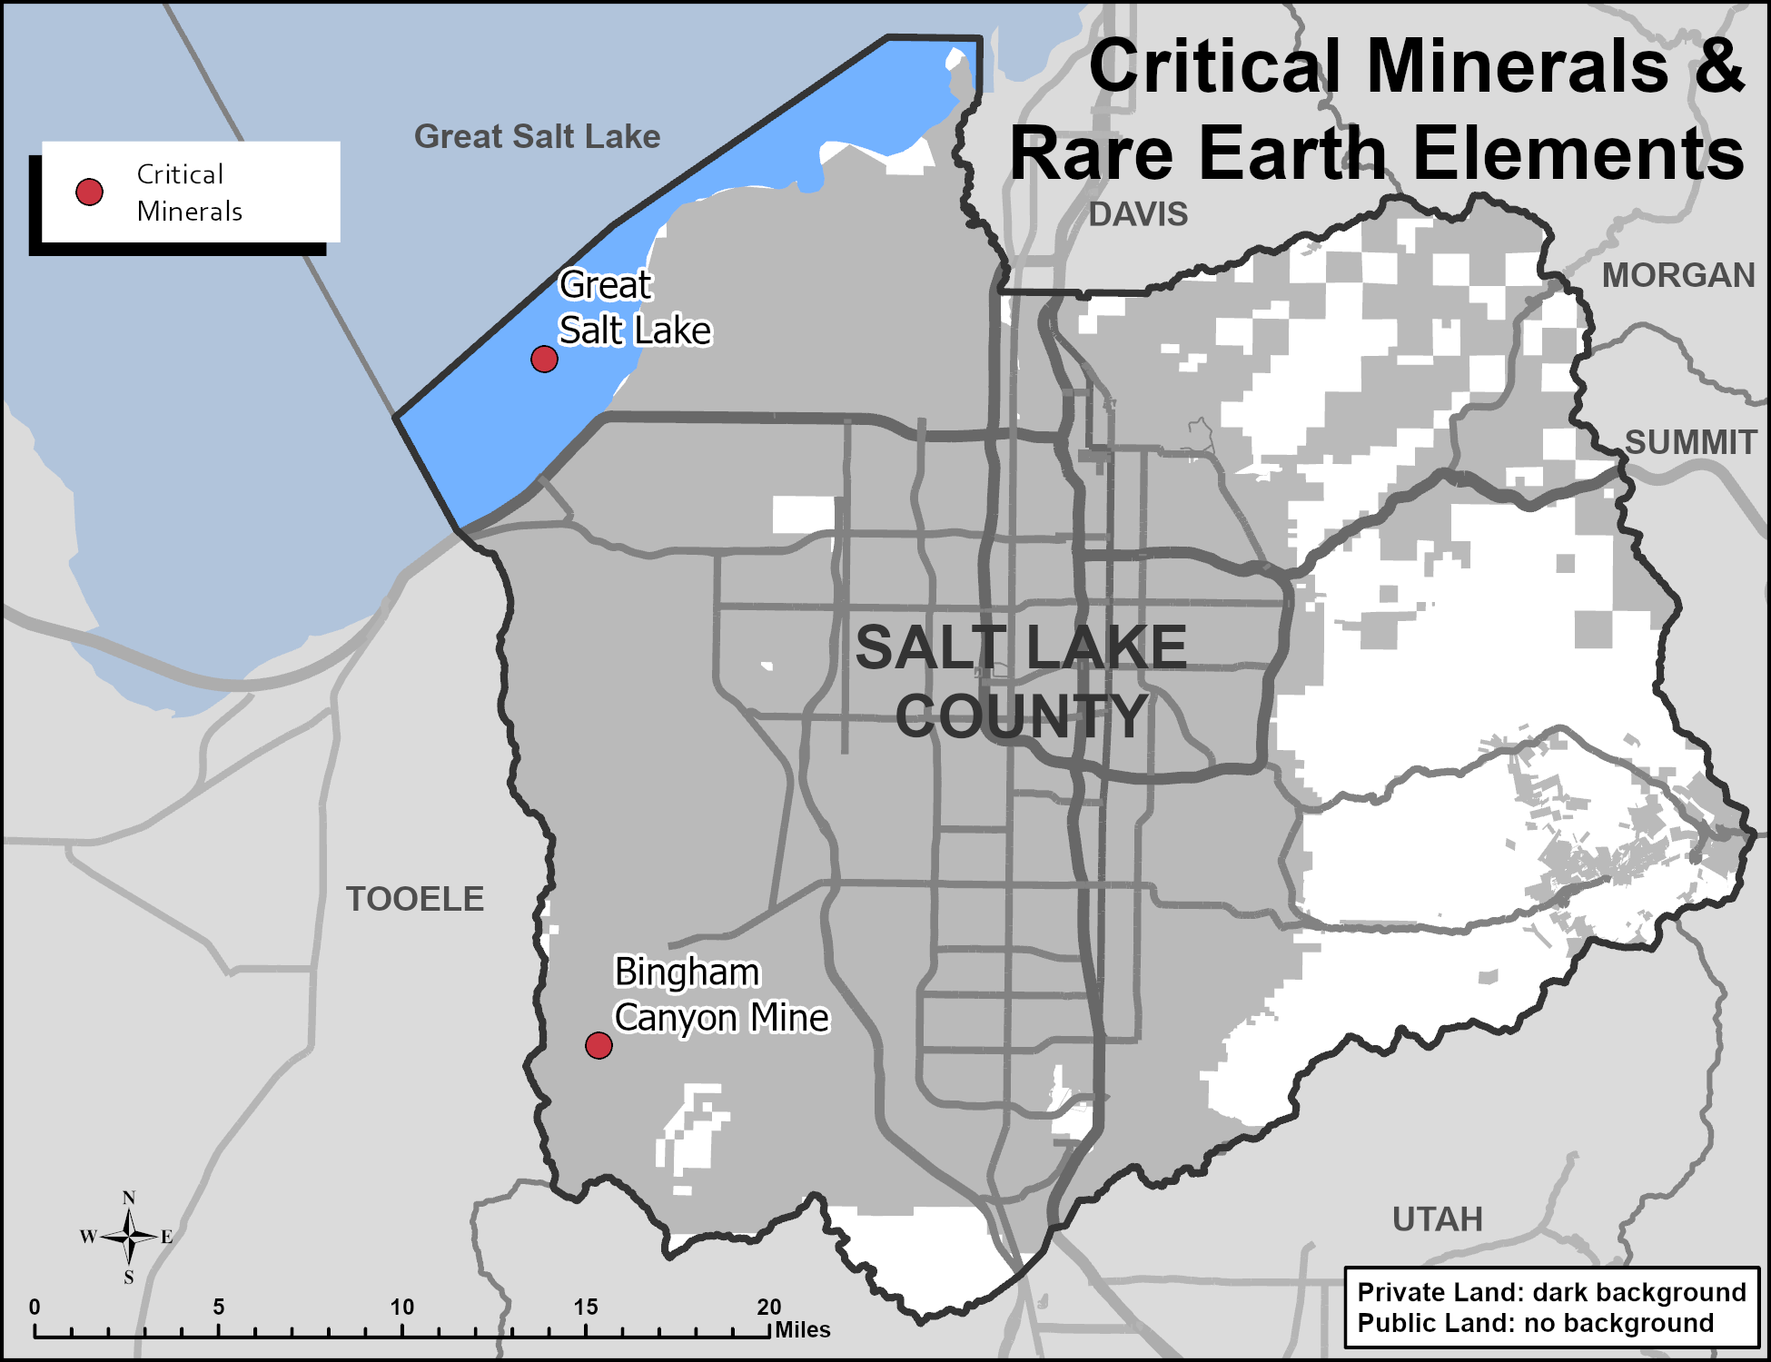 Source: Critical Minerals of Utah, Utah Geological Survey Circular 129 (2020).[1]

Management Setting

Resource Context
Public lands in the County are not known to contain critical minerals or rare earth elements. However, private lands in the Oquirrh Mountains as well as the waters of the Great Salt Lake do contain these resources and are currently extracted or have potential for extraction in the future.

Legal Context
Laws regarding the extraction of critical minerals and rare earth elements are similar to those for other locatable minerals. Please refer to Chapter 17 Mining for legal context.

Findings
For this plan, critical minerals and rare earth elements are defined by the United States Geological Survey (USGS) in the 2022 Final List of Critical Minerals.[2] The presence of these minerals in the County is based on the Utah Geological Survey’s (UGS) Critical Minerals of Utah.[1]

Table 3.1 Critical minerals located in Salt Lake County
MINERAL | LOCATION | MINERAL | LOCATION
Bisthmus | Bingham Canyon Mine | Palladium | Bingham Canyon Mine
Lithium | Great Salt Lake | Rehenium | Bingham Canyon Mine
Magnesium | Great Salt Lake | Tellurium | Bingham Canyon Mine
Platinum | Bingham Canyon Mine | - | -
Source: Critical Minerals of Utah, Utah Geological Survey Circular 129 (2020).[1]

The Bingham Canyon Mine operated by Rio Tinto is a major producer of copper, but the mine produces other critical minerals as byproducts of its primary copper production, including platinum, palladium, rhenium, and tellurium.[1]

The UGS identifies magnesium and lithium resources found in the concentrated brines of the Great Salt Lake. Previously, the US Magnesium mine in Tooele County primarily produced magnesium. Lithium was also produced.as a byproduct of magnesium processing, as lithium concentrations in the Great Salt Lake were insufficient for direct extraction using current technologies.

Other critical minerals and rare earth elements are not currently found in Salt Lake County.[1]

Desired Future State

Public lands in Salt Lake County are managed to protect critical watersheds, air quality, and wildlife habitat, provide recreation opportunities, and prevent wildland fire. Mining activities used to extract critical minerals and rare earth elements on these lands are generally incompatible with these management goals and will be limited.

Management Objective and Associated Policies
and Guidelines

Management Objective
- Mining of critical minerals and rare earth elements are not expanded beyond existing mining claims.
- Mining of critical minerals and rare earth elements is conducted in a manner that minimizes surface disturbance, sedimentation, air and water pollution, and visual impairment.

Policies and Guidelines
- Coordinate with state and federal agencies in land use decisions related to mining of critical minerals and rare earth elements
- Ensure mining projects within areas subject to FCOZ comply with County FCOZ ordinance in the Chapter titled “Foothills and Canyons Overlay Zone (FCOZ),” including slope-protection standards, skyline and ridgeline development designations, tree and vegetation protection, stream corridor and wetlands protection, and wildlife-habitat protection.
- Plan for and support appropriate landscape buffering surrounding mining operations to mitigate the noise, water quality, and visual impacts of mining.
- Restore lands disturbed by mining of critical minerals and rare earth elements through effective reclamation techniques. Monitor reclamation to ensure effectiveness.
- Retain sufficient bonding until an appropriate percentage of the potential vegetation ground cover on a mining or extraction site has been re-established.

References

[1] Mills, Stephanie E. and Andrew Rupke. 2020. Critical Minerals of Utah. Utah Geological Survey Circular 129. https://ugspub.nr.utah.gov/publications/circular/c-129.pdf.

[2] US Geological Survey. 2022. Final List of Critical Minerals. Department of the Interior. https://d9-
wret.s3.us-west-2.amazonaws.com/assets/palladium/production/s3fs-
public/media/files/2022%20Final%20List%20of%20Critical%20Minerals%20Federal%20Register%20N
otice_2222022-F.pdf

Utility Corridors

Utility corridors are linear tracts of land set aside for the placement of the above- and below-ground infrastructure that transports or conveys raw materials, processed materials, and energy.

Related Resources:
- Land Access
- Land Use
- Pipelines and Infrastructure

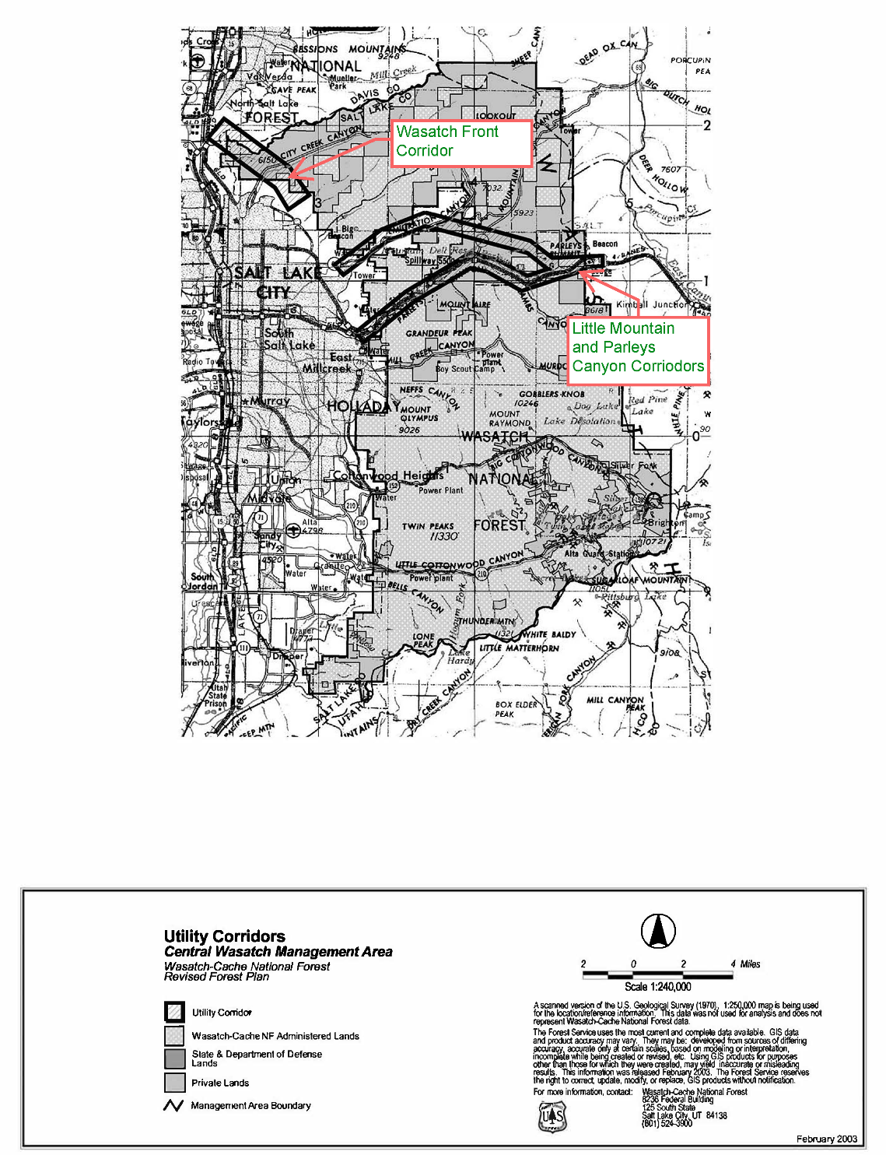
Source: Revised Forest Plan, Wasatch-Cache National Forest, 2003.[1]

Management Setting

Resource Context
With five oil refineries located in the County, the area is a major hub for oil and natural gas pipelines.

Legal Context
The primary federal laws regulating utility corridor placement on BLM and USFS lands are the Federal Land Policy and Management Act of 1976 (FLPMA) for BLM and the National Forest Management Act of 1976 (NFMA) for the USFS. Both FLPMA and NFMA require federal agencies to complete resource management plans that list and describe future goals and objectives for managing lands within their jurisdictions. These documents include any proposed locations for utility corridors.

Federal agency decisions regarding utility corridors must comply with the National Environmental Policy Act of 1969 (NEPA), which stipulates that all projects with the potential to impact the environment must be evaluated via an environmental assessment, environmental impact statement, and other documentation. Regulatory laws that require avoidance, minimization, and possibly mitigation include but are not limited to:

- Antiquities Protection Act of 1993, which protects significant cultural resources, historic properties, and paleontological resources from negative impacts.
- Clean Water Act of 1972, which, among other requirements, regulates the discharge of pollutants and fill material into certain jurisdictional waters (also known as “waters of the United States”). Endangered Species Act, which is administered by the US Fish and Wildlife Service (USFWS), regulates potential project impacts to threatened and endangered species.
- Section 368 of the Energy Policy Act of 2005, which directs federal agencies to designate energy corridors on federal lands in the western United States. This set of regulations was enacted with the goal to “improve reliability, relieve congestion, and enhance the capability of the national grid to deliver electricity”.[2]

Findings
Parleys Canyon and Emigration Canyon have existing rights-of-way on USFS lands for a variety of utilities and pipelines.[2] There are no Section 368 Energy Corridors in Salt Lake County.[3, 4]

Table 4.1 Existing major utility corridors
CORRIDOR NAME | OWNER | CORRIDOR WIDTH | UNDER-GROUND | OVER-HEAD | SURFACE
Little Mountain and Parleys Canyon | US Forest Service | 0.5 mile | Yes | Yes | No
Wasatch Front | US Forest Service | 1 mile | Yes | Yes | No
Source: Revised Forest Plan Wasatch-Cache National Forest, 2003 [2]

Desired Future State

All future utility infrastructure is located within existing utility corridors, with continued consideration of the impact to natural features, when practical. If new utility corridors must be established, then corridors should be placed to mitigate impacts to natural and visual resources. Salt Lake County desires to have active participation in decisions related to the placement of new utility corridors on public lands.

Management Objective and Associated Policies
and Guidelines

Management Objectives
- Existing and designated utility corridors and rights-of-way are utilized whenever possible.
- New utility corridors shall mitigate negative impacts to natural and visual resources.

Policies and Guidelines
- Ensure utility corridors comply with County ordinance in the Chapter titled “Foothills and Canyons Overlay Zone (FCOZ),” when located within areas subject to FCOZ.
- When located within areas subject to FCOZ, require utility providers to establish stream setbacks, protect vegetation, site development appropriately, and implement stormwater best management practices when planning the design and construction of new utility infrastructure.
- When practical, encourage utility providers to place new and existing utilities underground and within existing roadways or existing shoulders to minimize wildfires and impacts to natural features, such as natural vegetation patterns and land forms. When practical, avoid placement of rights-of-way on ridge tops, narrow drainages, or other places where visual or physical impacts will be obvious.
- In areas subject to FCOZ, ensure new corridors avoid slopes greater than 30 percent.

References

[1] US Forest Service. 2003. Revised Forest Plan for the Wasatch-Cache National Forest. Central Wasatch Utility Corridors Map. https://www.fs.usda.gov/sites/nfs/files/legacy-media/uinta-wasatch-cache/2003%20WC%20Revised%20Forest%20Plan%20Chapter%204B%20-%20Central%20Wasatch%20Utility%20Map.pdf.

[2] US Forest Service. 2003. Revised Forest Plan for the Wasatch-Cache National Forest. Table G84, page 4-55. https://www.fs.usda.gov/sites/nfs/files/r04/uinta-wasatch-cache/publication/Wasatch-Cache%20Forest%20Plan%202025.pdf.

[3] [BLM] Bureau of Land Management. ND. West-Wide Energy Corridor Guidebook. HDR, National Renewable Energy Laboratory. 64pg. https://www.blm.gov/sites/default/files/docs/2020-12/BLM_WestWideEnergyCorridor_Guidebook.pdf.

[4] Utah Automated Geographic Reference Center. 2026. Utah Energy Corridor Areas [GIS Feature Layer]. https://opendata.gis.utah.gov/datasets/utah::utah-energy-corridor-areas/explore?location=40.511898%2C-112.036140%2C-1.

Pipelines and Infrastructure

This resource consists of the primary physical structures and facilities used to convey and store raw materials, electricity, water, utilities, products, and people. This infrastructure is critical to support County residents as well as transmit resources through Salt Lake County to other parts of Utah and throughout the United States.

Related resources:
- Land Access
- Land Use
- Utility Corridors

Management Setting

Resource Context

Pipelines and infrastructure encompass a variety of resource types, the most common of which are listed and explained below.

Electrical Transmission: High-voltage electricity is conveyed from a generation source to load-center substations, where it’s transformed into lower-voltage electricity for distribution to end users.

Natural Gas Pipelines: Raw natural gas is moved from production areas to processing facilities and distributed to end users.

Oil Pipelines: Crude oil is extracted from the earth and transported through networks of pipes and pump stations to processing facilities and then distributed to consumers.

Hydrogen Pipelines: Manufactured products are transported through networks of pipes and pump stations from production areas to consumers.

Water Pipelines: Substantial infrastructure projects are used to transport large quantities of water over long distances through varying terrain and elevations from reservoirs and rivers to major population centers and agricultural users

Other Infrastructure: Other infrastructure systems in place include mechanical wastewater treatment facilities, sewer collection systems, sewage lagoons, and stormwater systems.

Telecommunications: Electronic information is transmitted and distributed to connect consumers to the Internet through infrastructure like broadband, typically transmitted through fiber-optic cable, which allows the high-speed transmission of large quantities of digital information to consumers and businesses.

Transportation Infrastructure: A network of major roads; highways; heavy and light rail tracks, stations, and associated facilities; and paved trails intended for bicycles and other non-motorized/small motorized transport equipment (e-bikes, e-scooters, etc.), used to transport goods and people within and across Utah.

Legal Context

Electrical Transmission: The Federal Powers Act 1921 (16 U.S.C. 12), as amended, provides for federal oversight of the bulk electrical transmission system by the Federal Energy Regulatory Commission (FERC). The Energy Policy Act of 2005 (among other items) enables FERC to facilitate transmission planning to meet the needs of utilities serving retail customers. In 1996, FERC issued Order No. 888, which opened all interstate transmission lines to use by any power generator to transmit power across the bulk transmission grid, provided the power generator pays tariffs to the transmission line utility owners. This is known as the Open Access Transmission Tariff (OATT). The FERC’s Order No. 889, sets standards of conduct for power generators utilizing OATT transmissions [Utah Code 54-17-9 (2019)].

Natural Gas Pipelines: Natural gas pipelines are constructed by private utility companies to move natural gas from production areas to end users (Utah Code 54-13). Gathering pipelines move extracted raw materials from wellheads to processing plants, where natural gas is separated from other gasses, hydrocarbon gas liquids, and water. The refined natural gas is then pressurized and added to the mainline transmission system, which consists of large-diameter, high-pressure pipelines. Compressor stations along the network maintain pressure and move product down the line to storage areas, major industrial consumers, power plants, shipping ports, and distribution companies. From there, distribution transmission systems operate with smaller-diameter lines and lower pressure. Finally, service lines transport natural gas to the end users.

This planning document focuses on pipeline infrastructure located within designated utility corridors (typically major transmission lines) but may also include some gathering and distribution lines.

Oil Pipelines: Similar to the natural gas pipelines, the State of Utah grants local governments the authority to supplement the state and federal laws with its own regulations for oil and gas development. The State of Utah authorizes counties to enact any ordinances necessary to carry out their duties, so long as they are not repugnant to state or federal law.[1] The Pipeline and Hazardous Materials Safety Administration (PHMSA) exercise authority under the Pipeline Safety Act [49 U.S.C. 60101-60143 (2024)] to prescribe minimum safety standards governing the location, design, construction, operation, and maintenance of liquefied natural gas facilities in or affecting interstate or foreign commerce. Whereas FERC serves as the lead federal agency for satisfying compliance with NEPA [42 U.S.C. 4331-4336e (2024)] for liquefied natural gas facilities subject to its jurisdiction.[2]

Hydrogen Pipelines: The State of Utah grants local governments the authority to supplement the state and federal laws with its own regulations for oil and gas development. Utah authorizes counties to enact any ordinances necessary to carry out their duties, so long as they are not repugnant to state or federal law.[1] The US Department of Transportation (DOT), through PHMSA, has regulated hydrogen pipelines since 1970 via 49 CFR 192. This code of regulation stipulates that a minimal level of safety standard needs to be met when transporting natural and other gasses. Regulations apply to pipeline construction, material standards, operations, and maintenance of pipeline structures.

Water Pipelines: All water use within the State of Utah is governed by Utah Code, Title 73. Refer to Chapter 26 Water Rights for more information.

Telecommunications: The coordination of infrastructure and broadband information is regulated by Utah Code 72-19-202 (2025), which dictates the collection and maintenance of broadband data from providers and private or public entities.

For the purposes of telecommunication installation, utility access to the US interstate highway system, including the right-of-way areas, is regulated by Utah Code 72-7-108 (2018) and Utah Administrative Rule 907-64 (2013). These regulations facilitate longitudinal access to or use of any part of the right-of-way of a highway on the interstate system.

Placement and relocation of utility facilities that conflict with the construction or maintenance of highways (which applies to any and every facility, utility, or other structure not owned by the State of Utah) falls under the Utility Accommodation Administrative Rule, 930-7 (2024).

Other Infrastructure: The Federal Water Pollution Control Act of 1972, commonly referred to as The Clean Water Act 40 CFR § 1, Subchapters D, N, and O (Parts 100-140, 401-471, and 501-503), gives the US Environmental Protection Agency (EPA) the federal authority to set standards for allowable pollutants for point and nonpoint source discharge into waterways. The Utah Water Quality Act as amended establishes a framework for State oversight of water quality.

Transportation Infrastructure: There are 4 jurisdictional classifications of roads in Utah, as defined in Utah Code 72-3. The state has title to all rights-of-way for highways, roads, and streets designated as class A state highways. County roads are Class B roads and municipal (city) streets are Class C. Class D includes any other road, way, or other land surface route than has been or is established by use or constructed to provide for usage by the public for vehicles with four or more wheels that is not a class A, class B, or class C road, or an R.S. 2477 right-of-way, as that term is defined in Section 72-5-301 (2003). The state and county have joint undivided interest in the title to all rights-of-way for class D roads, unless the state or county has vacated and abandoned interest in the class D road [72-3-105(3) (2026)].

Recreational trails in Utah are defined by state code [79-5-102(3) (2022)] as multi-use paths used for: (a) muscle-powered activities, including: (i) bicycling; (ii) cross-country skiing; (iii) walking; (iv) jogging; and (v) horseback riding; and (b) uses compatible with the uses described in Subsection (3)(a), including the use of an electric assisted bicycle or motor assisted scooter, as defined in Section 41-6a-102. The Utah State Legislature directs the Division of Outdoor Recreation to coordinate the planning and development of trails with federal land management agencies, local governments, private landowners, and state agencies to assure that an integrated trails network is achieved [79-5-103(2) (2009)].

Findings
Based on spatial data from the US Energy Information Administration (EIA), Salt Lake County is bisected by multiple large pipelines and electrical transmission lines.

Table 5.1 Existing electrical transmission line length by type and voltage class
ALTERNATING CURRENT (AC) TRANSMISSION LINE LENGTH |  | SUBSTATIONS
Kilovolt Category | Total (miles) | Total (count)
Under 100 | 324.2 | 162
100–200 | 436.1 | 166
220–287 | 2.4 | 3
345 | 171.2 | 5
500 | 0.0 | 0
Unknown | 0.5 | 5
TOTALS | 934.4 | 341
Source: Homeland Infrastructure Foundation-Level Data, Electric Power Transmission Lines & Electrical Substations.[3]

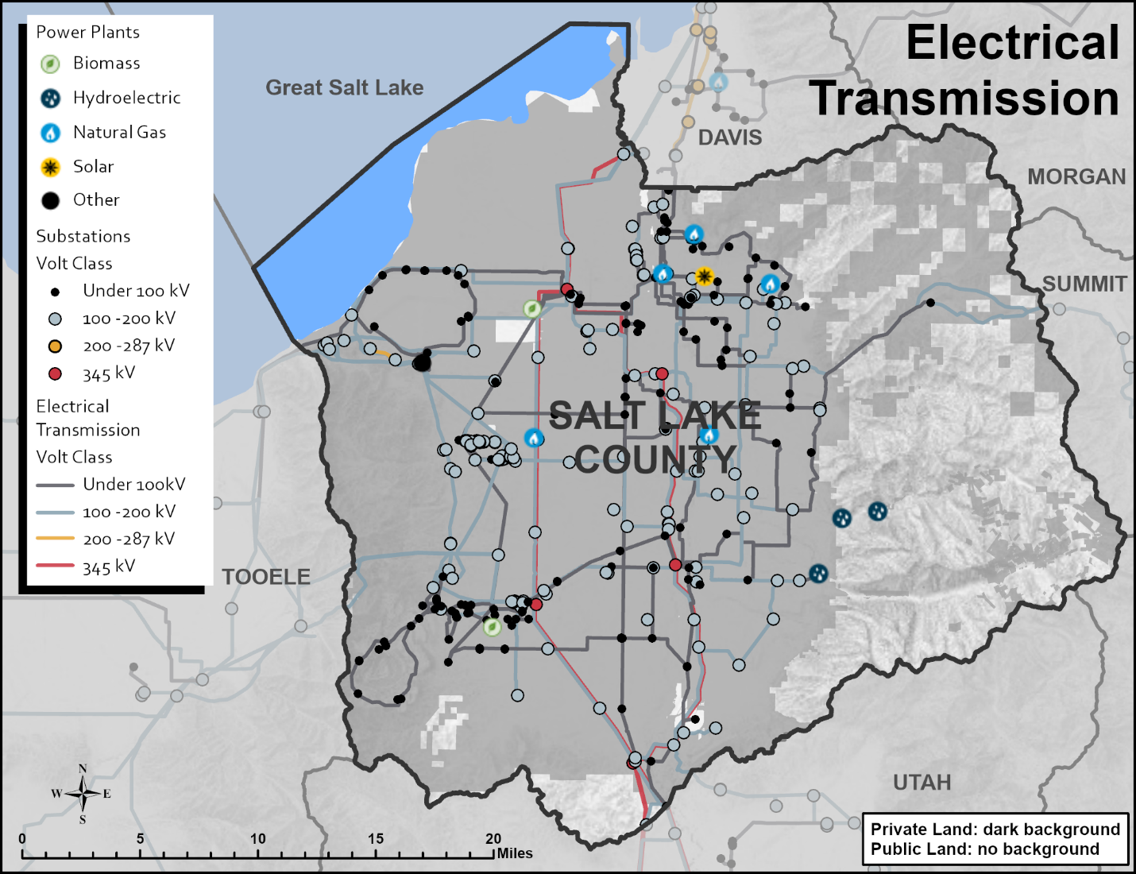
Source: Homeland Infrastructure Foundation-Level Data, Electric Power Transmission Lines & Electrical Substations.[3]
Table 5.2 Natural Gas Pipelines
NATURAL GAS PIPELINE LENGTH WITHIN SALT LAKE COUNTY
Operator | Total (miles)
Kern River Gas Transmission Co. | 31.8
Questar Pipeline Co. | 6.4
TOTAL | 38.1
Source: US Energy Information Administration, US Natural Gas Interstate and Intrastate Pipelines.[4]

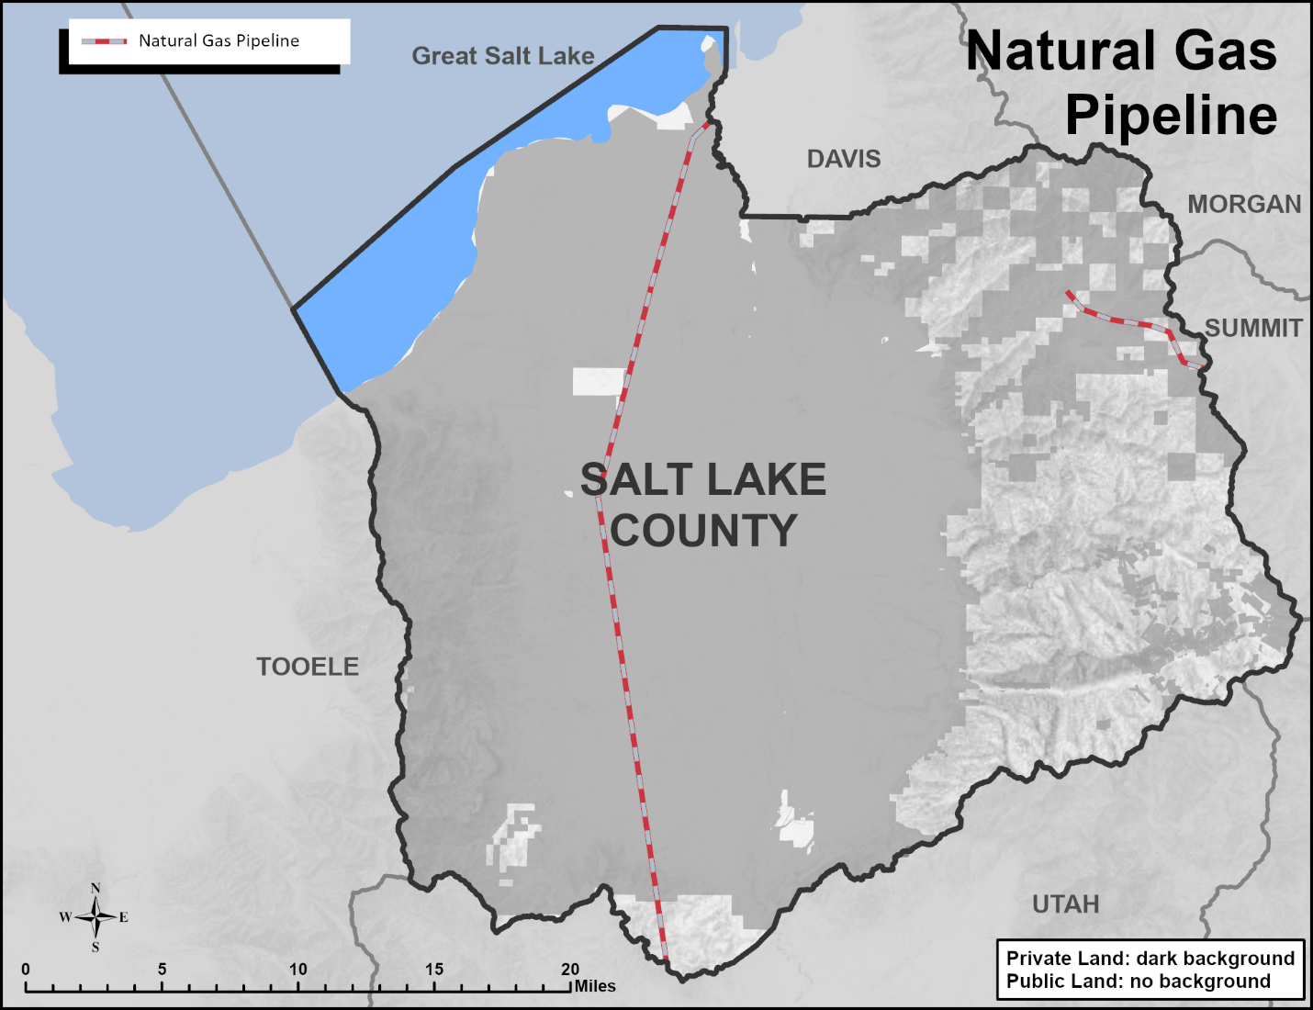
Source: US Energy Information Administration, US Natural Gas Interstate and Intrastate Pipelines.[4]
Table 5.3 Existing oil pipeline length by product type and operator
OIL PIPELINE LENGTH WITHIN SALT LAKE COUNTY
Type | Operator | Pipeline | Total (miles)
Crude Oil Pipeline | Chevron | Salt Lake Crude | 15.6
Petroleum Product Pipeline | Chevron Pipeline Co. | Salt Lake Products | 3.4
Petroleum Product Pipeline | Phillips 66 Pipeline | Pioneer | 2.1
Petroleum Product Pipeline | UNEV Pipeline | UNEV Pipeline | 13.6
TOTAL |  |  | 34.7
Source: US Energy Information Administration, US Crude Oil Pipelines, HGL Pipelines, and Petroleum Pipelines.[5]

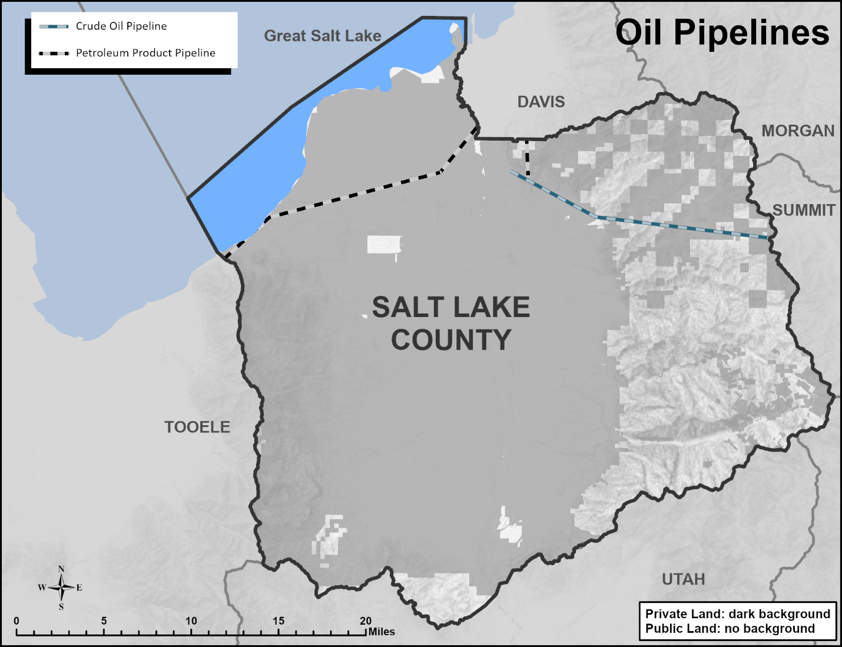 Source: US Energy Information Administration, US Crude Oil Pipelines, HGL Pipelines, and Petroleum Pipelines.[5]
Table 5.4 Existing and Proposed Fiber Optic Cable
Title | Owner | Status
Statewide Fiber Network | Multiple | Existing
VMS I-15 between 12300 S and Bangerter Hwy | UDOT | Proposed
Mill Creek Canyon TeleComm | Salt Lake County | Proposed
Source: Utah Department of Transportation fiber program features services [6,7] and Salt Lake County [8]

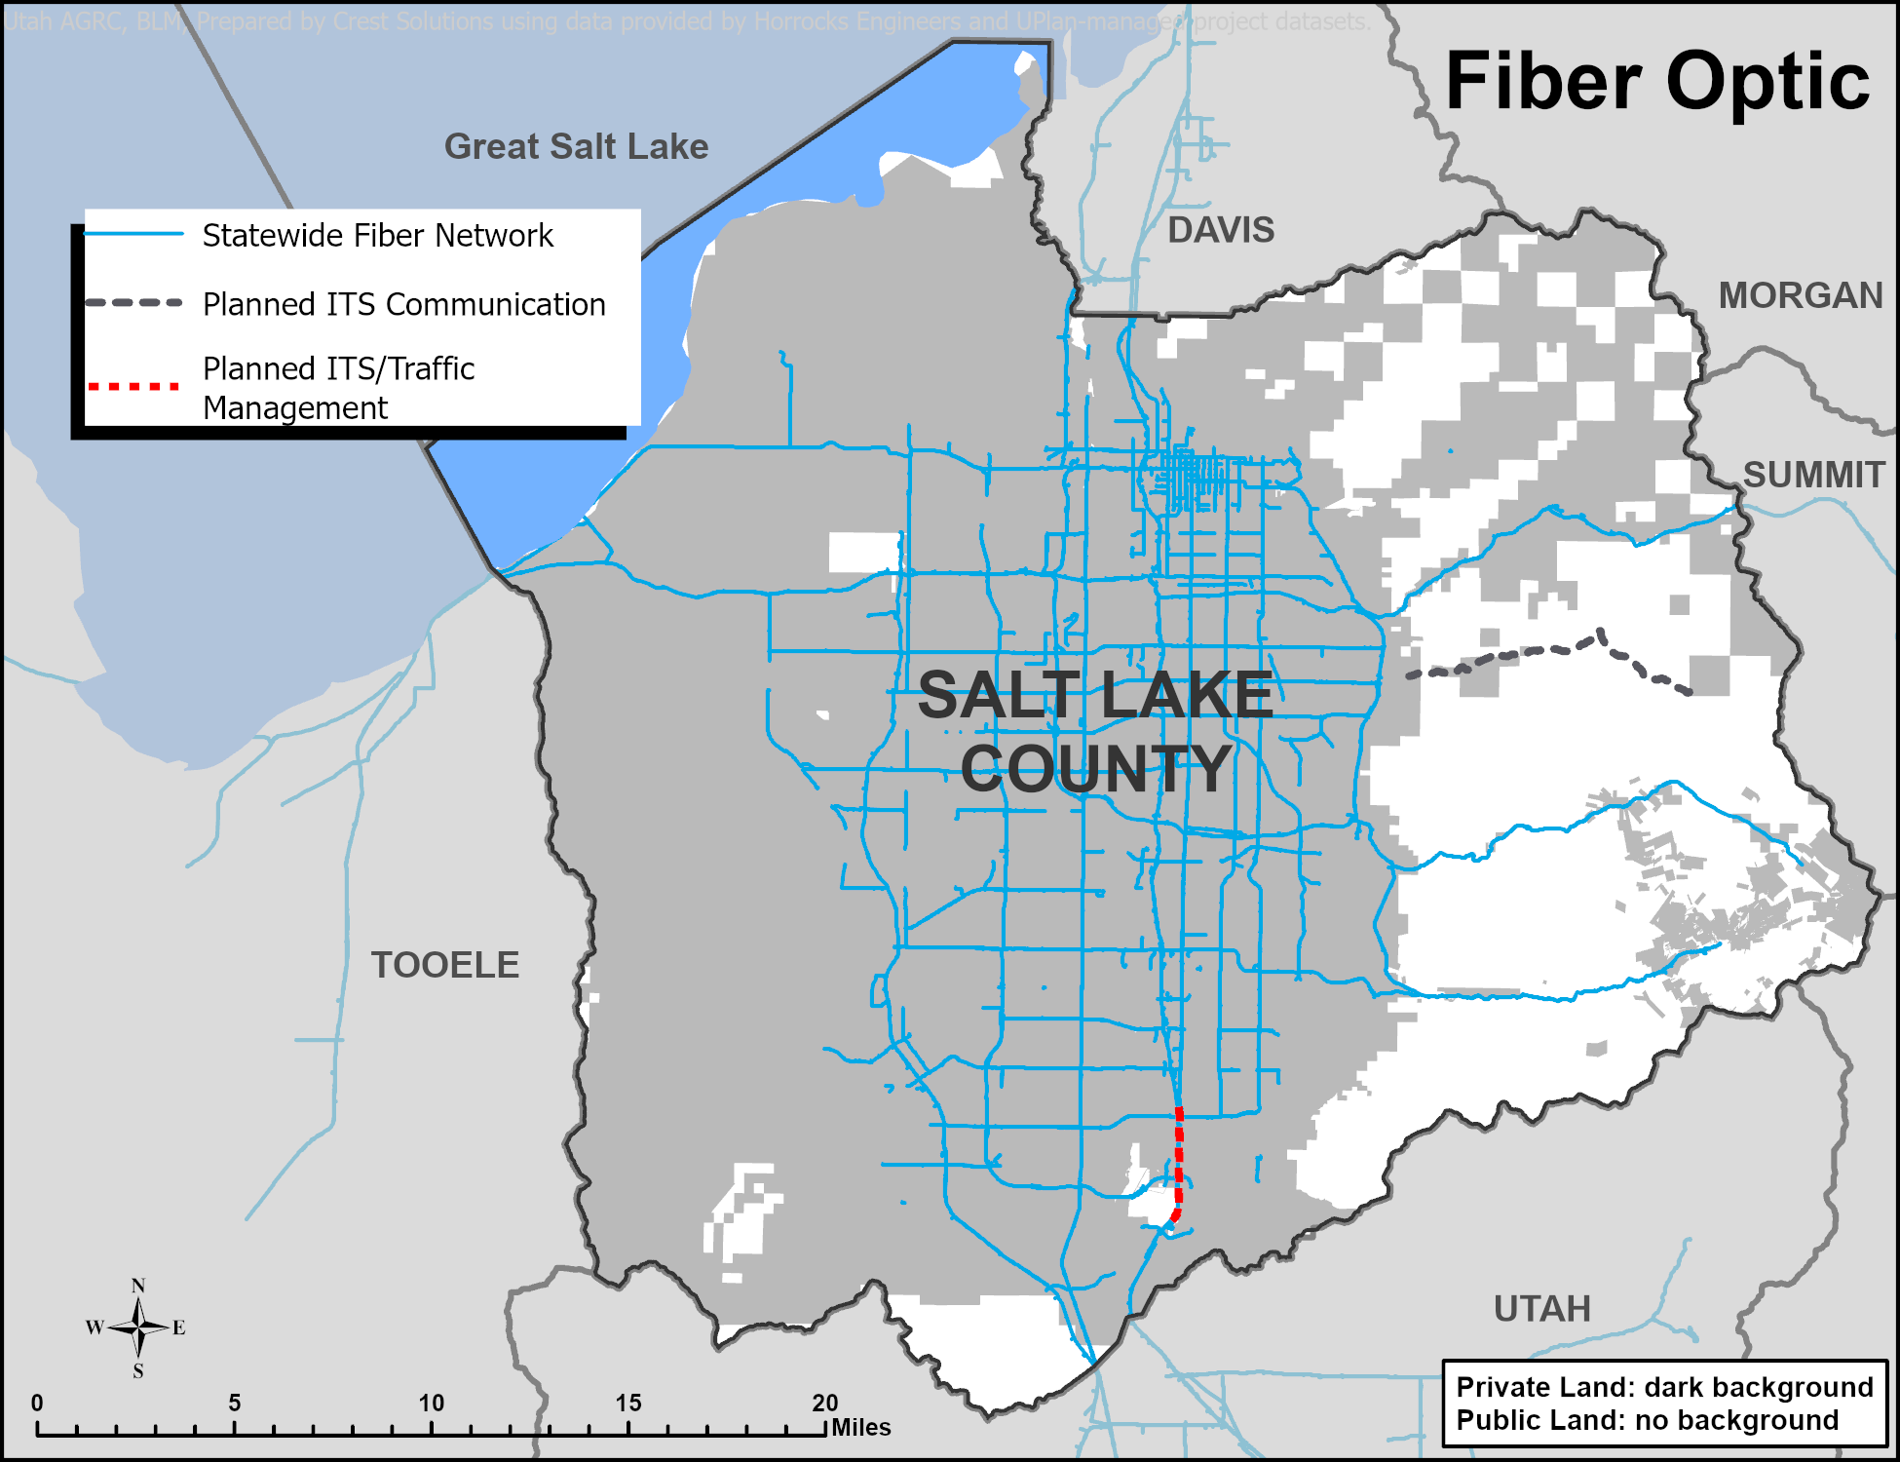
Source: Utah Department of Transportation fiber program features services [6,7] and Salt Lake County [8]]
Table 5.5 Active municipal sewer wastewater treatment facilities
FACILITIES
Facility Name | NPDES Permit | Type | Discharge Location
Magna Water & Sewer District | UT0021440 | Mechanical | Kersey Creek
SLC Water Reclamation Facility | UT0021725 | Mechanical | Oil Drain Canal then to the Salt Lake
SO. Valley Water Reclamation | UT0024384 | Mechanical | Jordan River
Central Valley Water Reclamation | UT0024392 | Mechanical | Mill Creek to Jordan River
Jordan Basin Water Reclamation Facility | UT0025852 | Mechanical | Jordan River
Source: Utah Department of Environmental Quality, Division Water Quality, UPDES Dischargers, public-owned wastewater treatment facility discharge.[9]

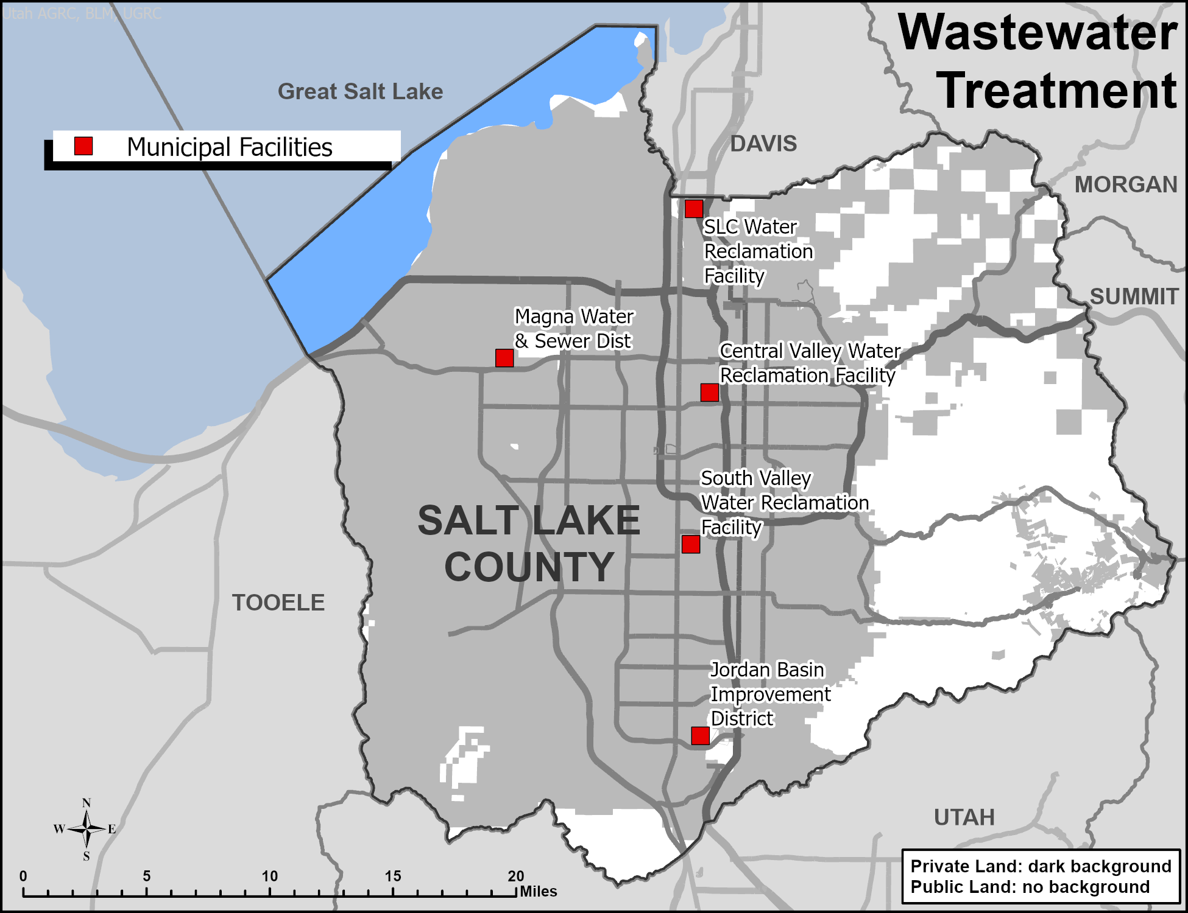
Source: Utah Department of Environmental Quality, Division Water Quality, UPDES Dischargers, public-owned wastewater treatment facility discharge.[9]
Table 5.6 Existing and planned roadways length by functional class
ROADWAY LENGTH
Functional Class | Existing Total (Miles) | Planned Total (Miles)
Interstate | 305.6 | 0.0
Other Freeway and Expressway | 29.9 | 0.0
Other Principal Arterials and Minor Arterial | 545.1 | 14.4
Major Collector & Minor Collector | 449.4 | 17.1
Local (UDOT only) | 9.3 | 0.0
TOTAL | 1,339.3 | 31.5
Source: Utah Department of Transportation, roadway functional class.[10]

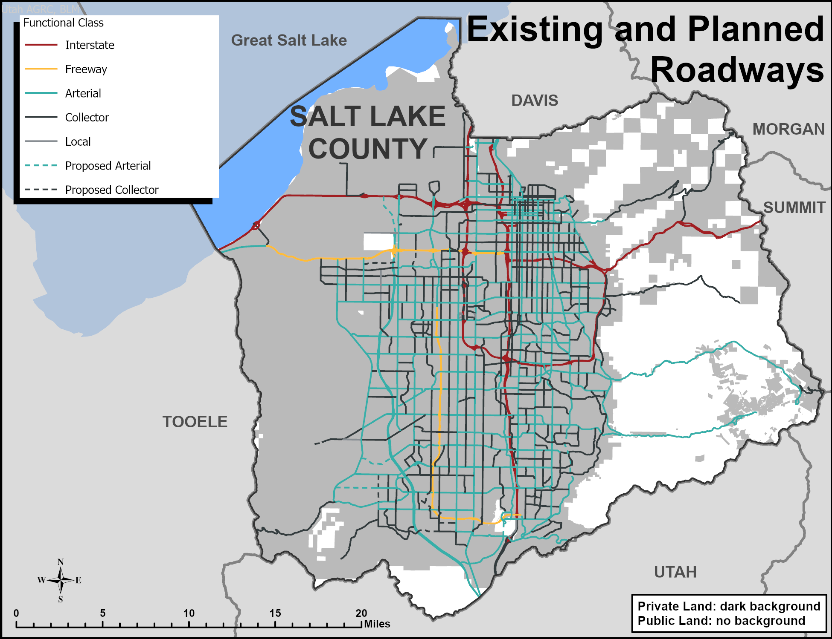
Source: Utah Department of Transportation, roadway functional class.[10]

Table 5.7 Shared Use Trails
Shared Use Trails in Salt Lake County | Miles
Existing Shared Use Trails | 527.3
Proposed Utah Trail Network (UTN) | 238.7
Other Proposed Shared Use Trails (some overlap with UTN) | 211.8
Sources: UGRC [11] and UDOT [12]

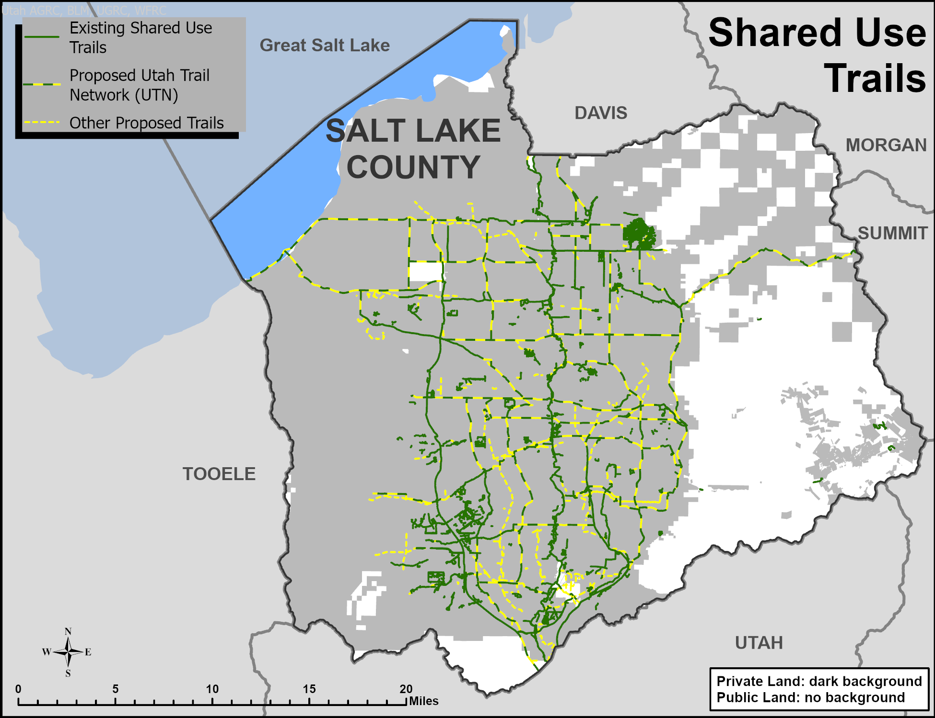
Sources: UGRC [11] and UDOT [12]

Table 5.8 Existing railroad length by operator and division
TRACK LENGTH
Operator | Division | Total (miles)
Utah Transit Authority | Front Runner | 41.8
Utah Transit Authority | TRAX | 101.6
Union Pacific | Multiple | 288.1
Salt Lake Garfield & Western Railway | Unknown | 17.9
Other | Unknown | 14.9
TOITAL |  | 464.3
Source: Utah Geospatial Resource Center data portal, railroads.[13]

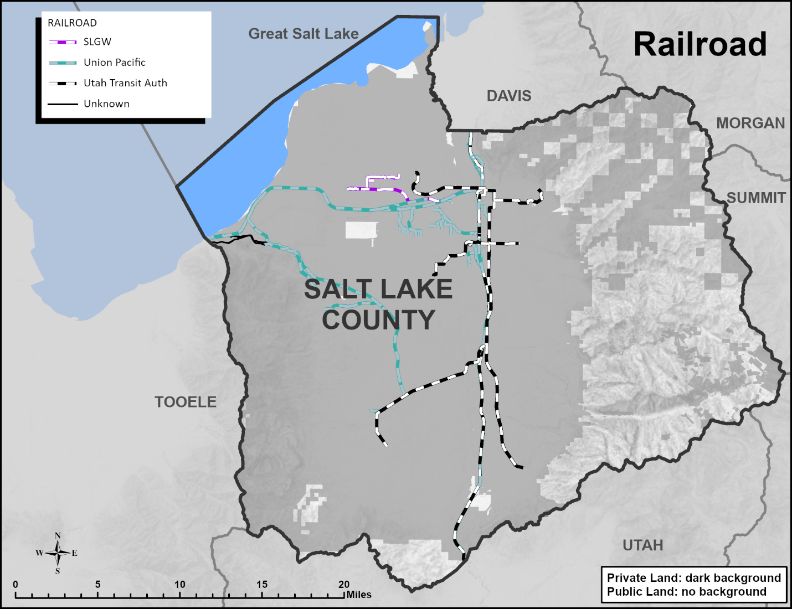
Source: Utah Geospatial Resource Center data portal, railroads.[13]

Desired Future State

Pipelines and infrastructure are sufficient to provide current residents of Salt Lake County with reliable and affordable utilities, energy, and transportation. The infrastructure currently used to convey energy, materials, and people through Salt Lake County to other locations is placed along existing transmission corridors and rights-of-way to avoid impacts on water, land, and ecosystems. Additional information may be needed to provide reliable and affordable utilities and energy to support future population growth, which may require additional transmission corridors. Additional planning and design for expanded, multi-modal transportation infrastructure will also be needed to provide adequate mobility for the projected population increase in Salt Lake County.

Management Objectives and Associated Policies
and Guidelines

Management Objectives
- To the extent practical, electricity infrastructure, including power lines, substations, and other important components should avoid visual and environmental impacts to natural landscapes and the community
- Transportation infrastructure should support the development of a “complete” and multi-modal transportation network.

Policies and Guidelines
- In areas subject to FCOZ, ensure pipelines and Infrastructure comply with County FCOZ ordinance in Chapter 19.72.17
- Install new or upgraded infrastructure underground whenever practical (County Ordinance 19.79.030), with the exception of transmission systems installed in the two main north-south transmission corridors.
- Ensure new infrastructure is designed and installed according to the goals outlined in the Wasatch Canyons General Plan and West General Plan regarding aesthetics, environmental and water quality, and the character of the canyons.
- Ensure infrastructure development, maintenance, and repair are conducted in a manner that protects water quality.
- In making decisions about expanded and new transportation infrastructure, give rail and non-motorized transportation equal priority with vehicular transportation.

References

[1] Intermountain Oil and Gas BMP Project. 11/4/2021. Utah County and Municipal Law. Boulder, CO. https://www.oilandgasbmps.org/laws/utah_localgovt_law.html.

[2] McIntyre, Keven & H. Elliott. 2018. Memorandum of Understanding Between The Department Of Transportation and the Federal Energy Regulatory Commission Regarding Liquefied Natural Gas Transportation Facilities. Memorandum, 4 pg. https://www.phmsa.dot.gov/sites/phmsa.dot.gov/files/docs/news/64706/ferc-phmsa-mou.pdf.
[3] Homeland Security & Emergency Management Agency. 2023. Electric Power Transmission Lines Homeland Infrastructure Foundation-Level Data [GIS Feature Layer]. https://www.arcgis.com/home/item.html?id=d4090758322c4d32a4cd002ffaa0aa12.

[4] US Energy Information Administration. 2020a. Natural Gas Pipelines. GIS Data. https://www.eia.gov/maps/layer_info-m.php

[5] US Energy Information Administration. 2020b. Crude Oil Pipelines, HGL Pipelines, Petroleum Pipelines. GIS Data. https://www.eia.gov/maps/layer_info-m.php.

[6] Utah Department of Transportation. 2026a. UDOT Fiber Network [MapServer]. https://central.udot.utah.gov/server/rest/services/Fiber/UDOT_Fiber_Network/MapServer/6.

[7] Utah Department of Transportation. 2026b. UDOT Statewide Planned Fiber Infrastructure 2026 [Feature layer]. https://services.arcgis.com/pA2nEVnB6tquxgOW/arcgis/rest/services/UDOT_Statewide_Fiber_Infrastructure/FeatureServer.

[8] Salt Lake County. 2026. Millcreek Canyon Planned Telecommunications Line [GIS Data].

[9] Utah Department of Environmental Quality, Division Water Quality, UPDES Dischargers, public-owned wastewater treatment facility discharge. https://opendata.gis.utah.gov/datasets/utahdeq::utah-updes-dischargers/about.

[10] Utah Department of Transportation. 2022. Roadway Functional Classification. GIS Data. https://uplan.maps.arcgis.com/home/item.html?id=86270f0f616c4e3695344c1f87b9dcb0.

[11] Utah Geospatial Resource Center Data Portal. 2026. Utah Trails and Pathways. https://opendata.gis.utah.gov/datasets/utah-trails-and-pathways/about.

[12] Utah Department of Transportation. 2025. Utah Trail Network Master Plan [GIS Feature Layer]. https://services.arcgis.com/pA2nEVnB6tquxgOW/arcgis/rest/services/UTN_Trails_Merged_07_29_2025_2286b/FeatureServer.

[13] Utah Geospatial Resource Center Data Portal. 2017. Railroads. GIS Data. https://gis.utah.gov/data/transportation/railroads/.

